Machine Learning
Machine Learning And its types.
Machine Learning (ML) is usually divided into a few main types based on how the model learns from data. The four primary types are supervised,unsupervised,semi- supervised,and reinforcement learning.

  - 1.SUPERVISED LEARNING
Models are trained on labeled datasets , meaning the input data is paired with correct output.
- G0AL: Predict outcomes based on known examples.
- EXAMPLE: Spam detection , House price prediction.
  - Classification : Predicting discrete Categories or labels.
- Logistic Regression : used for binary outcomes.
  - Regression : Predicts continuous numerical values.
- Linear Regression : Best for identifying
- Random Forest: An ensemble method that combines multiple decision trees to improve accuracy and reduce overfitting.
- Bagging
Bagging focuses on reducing variance and preventing overfitting by training multiple versions of the same model independently.
How it works: It creates multiple random subsets of the original training data using bootstrapping (sampling with replacement). Each subset is used to train a separate model in parallel
Popular Algorithm: Random Forest (an ensemble of decision trees).
- Boosting
Boosting focuses on reducing bias by training models sequentially, where each new model attempts to correct the errors of its predecessor.
How it works: Models are added one at a time. Misclassified data points from previous rounds are assigned higher weights, forcing the next model to focus on the most "difficult"
Popular Algorithms: AdaBoost, Gradient Boosting, and XGBoost.

  - 2.UNSUPERVISED LEARNING
Models work with unlabeled data to find hidden patterns or structures without human guidance.
- GOAL: Find hidden patterns or groupings.
- EXAMPLE: Customer segmentation , Market basket analysis.
- Clustering : Groups similar data points together.
K-Means (Unsupervised Learning)
K-Means is the primary algorithm used for unsupervised learning, while KNN is a supervised learning algorithm.
K-Means is a clustering algorithm that discovers natural groupings within unlabeled data.
- Purpose: To partition data into distinct, non-overlapping clusters based on feature similarity.
- What 'K' Represents: The total number of clusters you want to form.
- How it Works: It iteratively assigns data points to the nearest cluster center (centroid) and then recalculates the centroids based on the mean of the assigned points until they stabilize.
- Key Applications: Market segmentation, image compression, and document clustering

a.Dimensionality : Simplifies large datasets by reducing the number of variables while retaning essential information.

Principal Component Analysis (PCA) is a dimensionality reduction technique used in machine learning and statistics. It helps simplify large datasets while preserving as much important information (variance) as possible.
Key Aspects of PCA:
- Dimensionality Reduction: It reduces the number of features in a dataset while keeping the most important information.
- Principal Components: PCA creates new, orthogonal (uncorrelated) features (PC1, PC2, etc.) that represent the directions of maximum variance in the data.
- Variance Maximization: The first principal component captures the highest variance, the second captures the next highest, and so on.
- Unsupervised Learning: It operates without needing target labels, making it ideal for data preprocessing, visualization, and noise reduction.
Steps in PCA Algorithm:
- Standardize the data: Scale features to have a mean of 0 and standard deviation of 1.
- Compute the Covariance Matrix: Identify relationships between variables.
- Calculate Eigenvectors and Eigenvalues: Determine the directions (eigenvectors) and magnitude (eigenvalues) of variance.
- Sort and Select: Sort eigenvalues in descending order and select the top

components.
- Project Data: Transform the original data into the new, lower-dimensional space.
Why Use PCA in Machine Learning?
- Faster Training/Inference: Fewer features mean algorithms process data faster.
- Prevents Overfitting: Reducing features helps models generalize better to new data.
- Data Visualization: Complex data can be projected down to 2 or 3 dimensions for plotting.
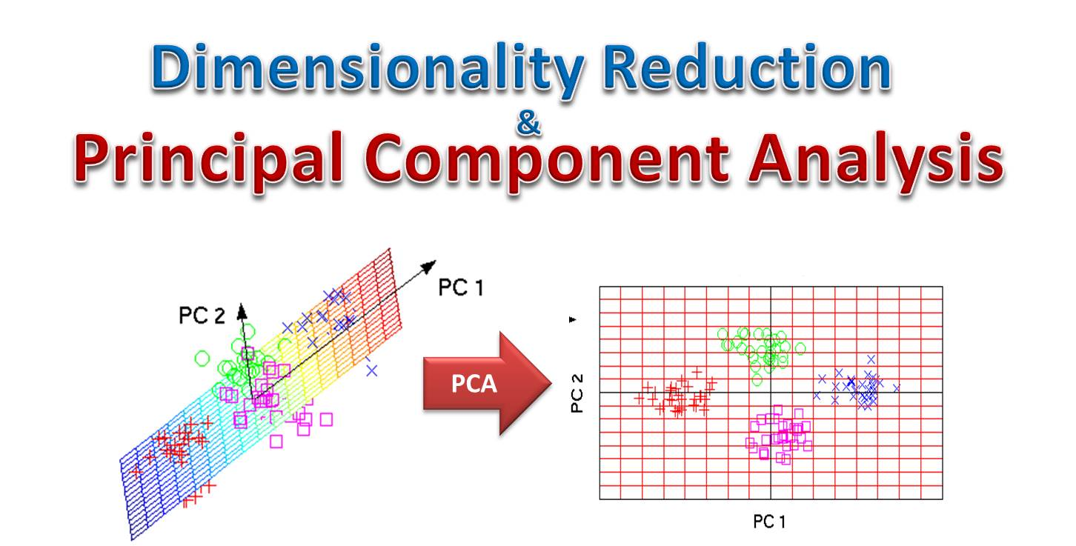

- Association Rules : Identifies relationships between variables in large databases(e.g., product recommendations).
Deep Learning is a branch of Machine Learning that focuses on using neural networks with many layers to learn patterns from large amounts of data. It is inspired by how the human brain processes information.
.

🔹 What is Deep Learning?
Deep learning uses artificial neural networks (ANNs) with multiple hidden layers to automatically learn features from data, instead of manually defining them.
It is a subset of Artificial Intelligence and is widely used in tasks like image recognition, speech processing, and natural language understanding.

🔹 Basic Structure of a Neural Network
A deep learning model consists of:
- Input Layer – Receives data
- Hidden Layers – Perform computations and feature extraction
- Output Layer – Produces final prediction

🔹 Key Concepts
- Neurons: Basic units that process input signals
- Weights & Biases: Parameters learned during training
- Activation Functions: Decide whether a neuron should activate (e.g., ReLU, Sigmoid)
- Loss Function: Measures error
- Backpropagation: Updates weights to reduce error

🔹 Common Types of Deep Learning Models
- Feedforward Neural Network (FNN) – Basic architecture
- Convolutional Neural Network (CNN) – Used for images
- Recurrent Neural Network (RNN) – Used for sequential data
- Long Short-Term Memory (LSTM) – Improved RNN for long sequences
- Generative Adversarial Networks (GANs): Use two competing networks (a generator and a discriminator) to create realistic new data, such as images, videos, or audio
- Transformers: Specialized models used heavily in natural language processing (NLP) for tasks like translation and text generation, forming the basis of large language models like GPT.

An Artificial Neural Network (ANN) is the basic model in Deep Learning inspired by the human brain.

🔸 Structure
- Input Layer – Takes input data
- Hidden Layers – Perform computations
- Output Layer – Produces result

🔸 How it Works
- Each neuron receives inputs
- Multiplies by weights + adds bias
- Passes through an activation function
- Output moves to next layer

🔸 Key Features
- Fully connected layers
- Learns patterns from data
- Uses backpropagation for training

🔸 Applications
- Classification (spam detection)
- Regression (price prediction)
- Basic pattern recognition

🔸 Limitations
- Not efficient for images
- Does not handle sequence data well
A Convolutional Neural Network (CNN) is designed mainly for image processing.

🔸 Key Idea
Instead of looking at the whole image at once, CNN scans small parts using filters.

🔸 Main Layers
- Convolution Layer
  - Applies filters to detect features (edges, textures)
- Pooling Layer
  - Reduces size (downsampling)
- Fully Connected Layer
  - Final classification

🔸 How it Works
- Detects edges → shapes → objects
- Builds hierarchical features

🔸 Applications
- Image recognition
- Face detection
- Medical imaging
- Object detection

🔸 Advantages
- High accuracy for images
- Reduces parameters compared to ANN

🔸 Limitations
- Requires large datasets
- Computationally expensive

A Recurrent Neural Network (RNN) is used for sequential data where order matters.

🔸 Key Idea
RNN has memory of previous inputs.

🔸 Structure
- Loops in the network allow information to persist
- Output depends on current + previous inputs

🔸 How it Works
Example: Sentence
“I love AI”
- Each word is processed step-by-step
- Previous words influence the next prediction

🔸 Applications
- Speech recognition
- Text prediction
- Time-series forecasting

🔸 Advantages
- Handles sequential data
- Captures temporal relationships

🔸 Limitations
- Vanishing gradient problem
- Difficult to train
- Short memory (improved by LSTM/GRU)

Feature | ANN | CNN | RNN
Data Type | General | Images | Sequential
Memory | ❌ No | ❌ No | ✅ Yes
Best For | Basic tasks | Vision tasks | Time/sequence data
Complexity | Low | Medium | High

- ANN: Basic neural network for general problems
- CNN: Best for image and spatial data
- RNN: Best for sequential and time-dependent data
- Deep Learning is a subset of Machine Learning that uses multi-layered neural networks to automatically learn patterns and features from large datasets.
Feature | Machine Learning | Deep Learning
Definition | Uses algorithms to learn patterns from data | Uses multi-layer neural networks to learn patterns
Subset Relation | Subset of AI | Subset of Machine Learning
Data Requirement | Works with small to medium data | Requires large datasets
Feature Engineering | Manual feature selection required | Automatically extracts features
Accuracy | Moderate | High (especially for complex tasks)
Training Time | Faster | Slower (needs more computation)
Hardware | Works on normal CPUs | Often requires GPUs/TPUs
Interpretability | Easier to understand | Hard to interpret (“black box”)
Examples of Algorithms | Decision Trees, SVM, KNN | ANN, CNN, RNN, GAN
Best For | Structured data | Images, audio, text

🔹 Key Differences Explained

1. Feature Learning
- In Machine Learning, humans must select features manually
- In Deep Learning, the model learns features automatically

2. Data Handling
- Machine Learning works well with smaller datasets
- Deep Learning performs best with big data

3. Complexity
- Machine Learning models are simpler
- Deep Learning models are complex neural networks

🔹 Example
- Machine Learning: Predict house prices using features like area, rooms
- Deep Learning: Recognize objects in images automatically

🔹 Short Exam Definition
Machine Learning is a subset of AI that uses algorithms to learn from data, while Deep Learning is a subset of Machine Learning that uses multi-layer neural networks for complex pattern recognition.

📌 Introduction to CNN
A Convolutional Neural Network (CNN) is a deep learning model mainly used for image classification and computer vision tasks. It automatically learns features like edges, textures, and shapes from images.

📌 CNN Architecture

1. Convolution Layer
- Applies filters (kernels) to extract features
- Produces feature maps

2. Activation Function (ReLU)
- Introduces non-linearity
- Formula:
f(x) = max(0, x)

3. Pooling Layer
- Reduces image size
- Types:
  - Max Pooling
  - Average Pooling

4. Flatten Layer
- Converts 2D matrix into 1D vector

5. Fully Connected Layer (Dense)
- Final classification layer

📌 Working of CNN
- Input image is passed
- Convolution extracts features
- Pooling reduces dimensions
- Flatten converts to vector
- Dense layer predicts class

📌 Advantages
- Automatic feature extraction
- High accuracy for images
- Reduces manual effort

Natural Language Processing (NLP)

1. Introduction
Natural Language Processing (NLP) is a branch of Artificial Intelligence (AI) that enables computers to understand, interpret, and generate human language. It combines linguistics, computer science, and machine learning to process text and speech data.

2. Importance of NLP
- Helps computers interact with humans naturally
- Automates text-based tasks (emails, chats, documents)
- Extracts meaningful insights from large text data
- Used in modern AI systems like chatbots and virtual assistants

3. Applications of NLP
- Chatbots and Virtual Assistants
- Sentiment Analysis (e.g., product/movie reviews)
- Machine Translation (Google Translate)
- Speech Recognition
- Text Summarization
- Spam Detection

4. Key Techniques in NLP

a. Tokenization
Breaking text into smaller units like words or sentences.
Example:
"I love NLP" → ["I", "love", "NLP"]

b. Stopword Removal
Removing common words like "is", "the", "and" that do not add much meaning.

d. Lemmatization
Converting words into their meaningful base form.
Example:
"better" → "good"

5. Basic NLP Workflow
- Text Collection
- Text Preprocessing (tokenization, cleaning)
- Feature Extraction
- Model Building
- Evaluation

6. Challenges in NLP
- Ambiguity in language
- Sarcasm detection
- Handling multiple languages
- Context understanding
- Large dataset requirements
- Slang and informal text

  - 3. SEMI-SUPERVISED LEARNING
A hybrid approach using a small amount of labeled data and a large amount of unlabeled data.
- USE CASE: When labeling data is expensive (like medical images)

  - 4. REINFORCEMENT LEARNING (RL)
An agent learns to make a sequence of decision through trial and error in a dynamic environment, receiving rewards for good actions and penalties for bad ones .
- GOAL;Gaming playing(like,chess, AI agents),self-driving cars.

